GATEWAY
MODBUS RTU to MODBUS TCP

Installation procedure:
- Connect RS485 or RS232 line to device port
- Connect power supply – 9V DC, min 250mA
- Connect PC to Ethernet port and use Web Browser to set parameters
Default IP: 192.168.0.2
Default Port /both Modbus and HTTP/: 502

Factory reset procedure: press RESET button on first COMM led flash after power on
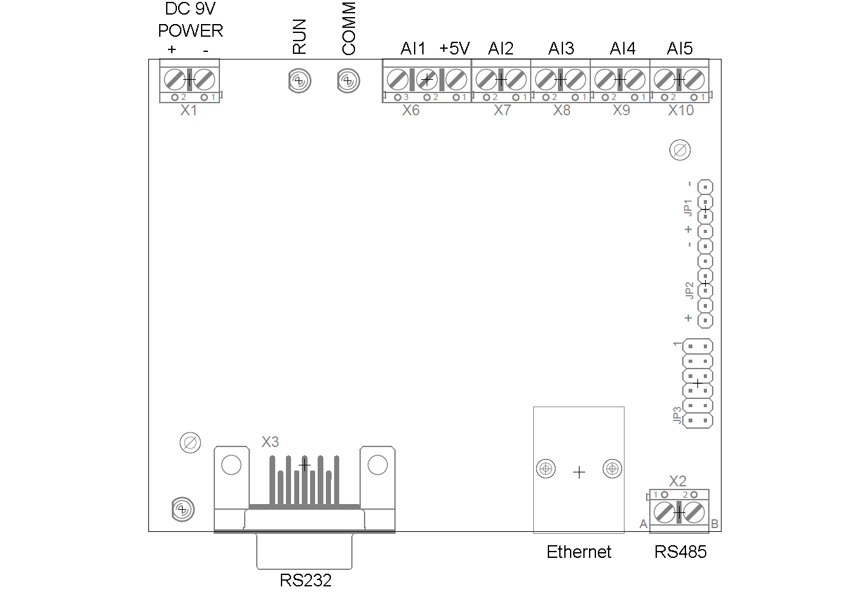

Holding Registers /Internal/
Modbus  Address | Description | Read/  Write
0 | Analog Input 0 | R
1 | Analog Input 1 | R
2 | Analog Input 2 | R
3 | Analog Input 3 | R
4 | Analog Input 4 | R
5 | Analog Input 5 | R
6 | Digital Output 0 | R/W
7 | Digital Output 1 | R/W
8 | Digital Output 2 | R/W
9 | Digital Output 3 | R/W
10 | Digital Output 4 | R/W
11 | Digital Output 5 | R/W
12 | Serial Interface Speed | R/W
13 | Serial Interface Parity | R/W
14 | Serial Interface Stop Bits | R/W
15 | Serial Interface Timeout | R/W
16 | Analog Input 0 NTC Temp | R
17 | Analog Input 1 NTC Temp | R
18 | Analog Input 2 NTC Temp | R
19 | Analog Input 3 NTC Temp | R
20 | Analog Input 4 NTC Temp | R
21 | Analog Input 5 NTC Temp | R

- Default Modbus TCP ID for accessing internal registers: 254
WEB interface
Use integrated web interface to monitor device and set parameters

Manual setting Digital Outputs
In “Digital Outputs” menu you can toggle the state of each digital output


Viewing analog inputs
You can view parameters of analog inputs in “Analog IO” menu
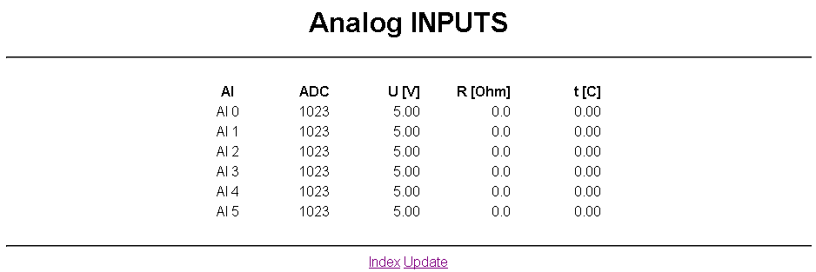
LAN Settings
LAN Settings can be changed in “LAN Settings” menu

Serial Interface Settings
Use “Serial Interface” menu to set parameters of the Serial Interface

- The changes take effect after reboot
Modbus Interface Status
The gateway shows Modbus Status in “Modbus Status” Menu
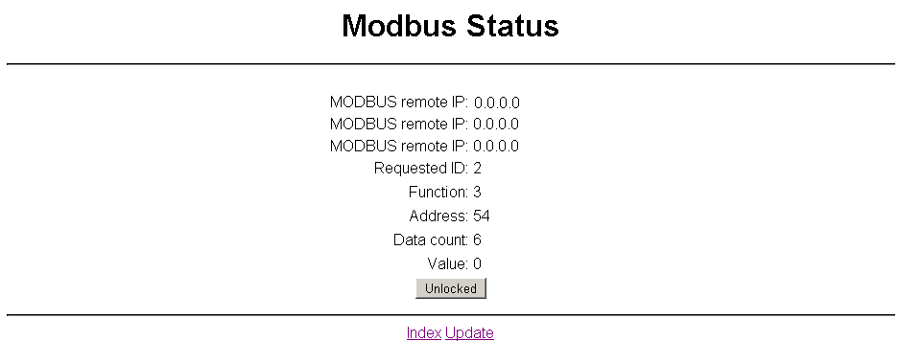

Restricting Modbus Access
Modbus TCP access can be restricted up to three IP addresses. To activate this function first request modbus data from the gateway and after that press “Unlocked” button

